Final Keyword Usage
Write a program to implement the following process
1. Inherit the final class.
final class Test
{
void display()
{
System.out.println("TEST");
}

}
class Sample extends Test
{
void display()
{
System.out.println("SAMPLE");
}
}
class MainClass
{
public static void main(String args[])
{
Sample s=new Sample();
s.display();
}
}
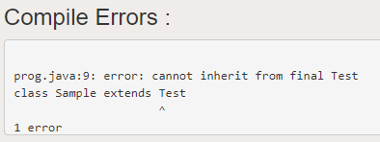
2. Declare object for final class.
class Test
{
void display()
{
System.out.println("TEST");
}

}
final class Sample extends Test
{
void display()
{
System.out.println("SAMPLE");
}
}
class MainClass
{
public static void main(String args[])
{
Sample s=new Sample();
s.display();
}
}


3. Override the final method

class Test
{
final void display()
{
System.out.println("METHOD TEST");
}

}
class Sample extends Test
{
void display()
{
System.out.println("METHOD SAMPLE");
}
}

class MainClass
{
public static void main(String args[])
{
Sample s=new Sample();
s.display();
}
}
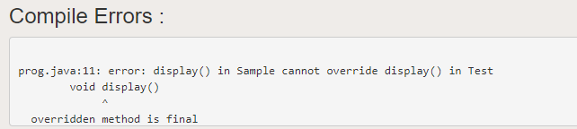

4. Call the final method.

class Test
{
void display()
{
System.out.println("METHOD TEST");
}

}
class Sample extends Test
{
final void display()
{
System.out.println("METHOD SAMPLE");
}
}

class MainClass
{
public static void main(String args[])
{
Sample s=new Sample();
s.display();
}
}

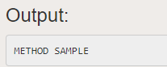

5. Assign local variable which is declared as final multiple times.

class Test
{
void display()
{
final int a=32;
a=56;
System.out.println(a);
}
}

class Sample extends Test
{
void display()
{
System.out.println("METHOD SAMPLE");
}
}

class MainClass
{
public static void main(String args[])
{
Sample s=new Sample();
s.display();
Test t=new Test();
t.display();
}
}

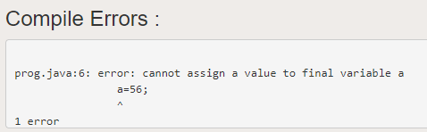

6. Assign local variable which is declared as final only one time.

class Test
{
void display()
{
final int a;
a=56;
System.out.println(a);
}
}

class Sample extends Test
{
void display()
{
System.out.println("METHOD SAMPLE");
}
}

class MainClass
{
public static void main(String args[])
{
Sample s=new Sample();
s.display();
Test t=new Test();
t.display();
}
}

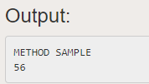

7. Assign instance variable which is declared as final inside the method

class Test
{
final int a;
void display()
{
a=55;
System.out.println(a);
}

}

class Sample extends Test
{
void display()
{
System.out.println("METHOD SAMPLE");
}
}

class MainClass
{
public static void main(String args[])
{
Sample s=new Sample();
s.display();
Test t=new Test();
t.display();
}
}

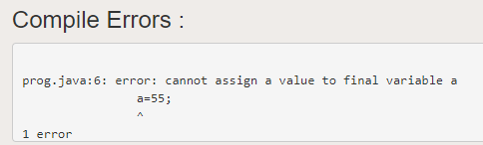

8. Assign instance variable which is declared as final during declaration.

class Test
{
final int a=34;
void display()
{
System.out.println(a);
}
}

class Sample extends Test
{
void display()
{
System.out.println("METHOD SAMPLE");
}
}

class MainClass
{
public static void main(String args[])
{
Sample s=new Sample();
s.display();
Test t=new Test();
t.display();
}
}

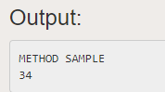

9. Assign instance variable which is declared as final inside the constructor.

class Test
{
final int a;
void display()
{
System.out.println(a);
}
Test()
{
a=676;
}
}

class Sample extends Test
{
void display()
{
System.out.println("METHOD SAMPLE");
}
}

class MainClass
{
public static void main(String args[])
{
Sample s=new Sample();
s.display();
Test t=new Test();
t.display();
}
}

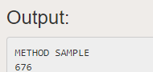

10. Assign static variable which is declared as final inside the constructor.

class Test
{
final static int a;
Test()
{
a=98;
}
void display()
{
System.out.println(a);
}
}

class Sample extends Test
{
void display()
{
System.out.println("METHOD SAMPLE");
}
}

class MainClass
{
public static void main(String args[])
{
Sample s=new Sample();
s.display();
Test t=new Test();
t.display();
}
}

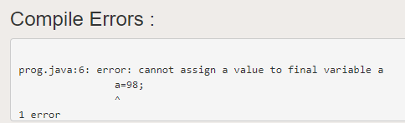

11. Assign instance variable which is declared as final during declaration.

class Test
{
final int a=34;
void display()
{
System.out.println(a);
}
}

class Sample extends Test
{
void display()
{
System.out.println("METHOD SAMPLE");
}
}

class MainClass
{
public static void main(String args[])
{
Sample s=new Sample();
s.display();
Test t=new Test();
t.display();
}
}

12. Assign instance variable which is declared as final inside the static block.
class Test
{
final static int a;
static
{
a=54;
}
void display()
{
System.out.println(a);
}
}

class Sample extends Test
{
void display()
{
System.out.println("METHOD SAMPLE");
}
}

class MainClass
{
public static void main(String args[])
{
Sample s=new Sample();
s.display();
Test t=new Test();
t.display();
}
}

